# Laboratory 3

Title of the Laboratory Exercise: Logical operations

1. Introduction and Purpose of Experiment

Students will be able to perform all logical operations using assembly instructions.

1. Aim and Objectives

Aim

To develop assembly language program to perform all logical operations

Objectives

At the end of this lab, the student will be able to

* + Identify the appropriate assembly language instruction for the given logical operations
  + Perform all logical operations using assembly language instructions
  + Get familiar with assembly language program by developing simple programs

1. Experimental Procedure

1. Write algorithm to solve the given problem

2. Translate the algorithm to assembly language code

3. Run the assembly code in GNU assembler

4. Create a laboratory report documenting the work

1. Questions:
   1. Consider the following source code fragment

*int a,b,c,d;*

*a= (b AND c) XOR d;*

*a=(b XOR c) OR d;*

Assume that *b, c, d* are in registers. Develop an assembly language program to perform this assignment statements. Assume that *b, c* are in registers and *d* in memory. Develop an assembly language program to perform this assignment statements.

* 1. Consider the following source code fragment

*int a ,b, c, d;*

*A = (b*c) / d;*

Perform multiplication and division by shift operations

1. Calculations/Computations/Algorithms

5.1 To perform *a= (b AND c) XOR d;*

Step 1: start

Step 2: declare variable a, b, c, d

Step 3: move value of b, c, d in ebx, ecx, edx registers Step 4: add ebx and ecx

Step 5: subtract ecx = ecx - edx

Step 6: move value of ecx to esi register

Step 7: move value of b to eax

Step 8: multiply eax = eax * c

Step 9: divide eax = eax / d

Step 10: add esi and eax

Step 11: move value of eax to a

Step 12: stop

5.2 To perform *a=(b XOR c) OR d;*

Step 1: start

Step 2: declare variable a, b, c, d

Step 3: move value of b, c, d in ebx, ecx, edx registers Step 4: xor between ebx ,ecx

Step 5: move value of ecx to eax register

Step 6: or between edx ,eax

Step 7: move value of eax to a

Step 8: stop

5.3 for performing *A = (b*c) / d;* by shift operations

Step 1: start

Step 2: assign value to register ebx

Step 3: sall $4,%ebx # ebx = ebx * (2^4)

Step 4: sarl $2, %ebx # ebx = ebx / (2^2)

Step 5: stop

1. Presentation of Results

6.1 For performing *a= (b AND c) XOR d;*

*a=(b XOR c) OR d;*

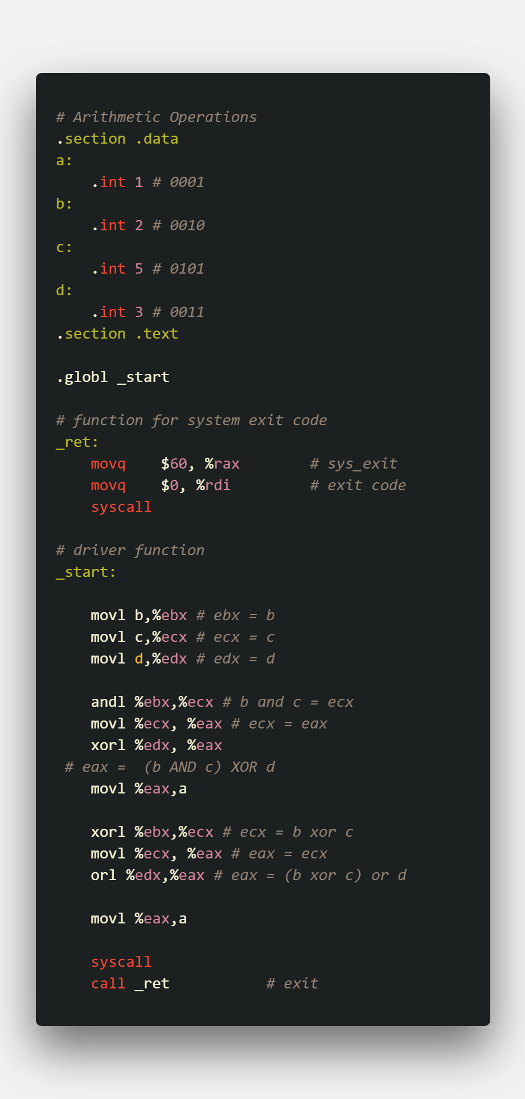

Figure 1 ASM code

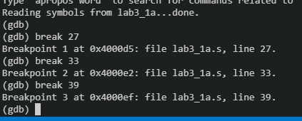

Figure 2 adding breakpoints

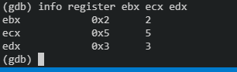

Figure 3 moved values to registers

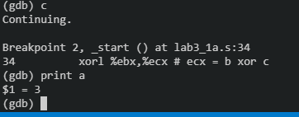

Figure 4 (b and c ) xor d

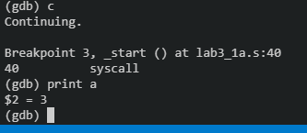

Figure 5 ( b xor c )or d

6.2 For performing A *= (b*c) / d;* by shift operations

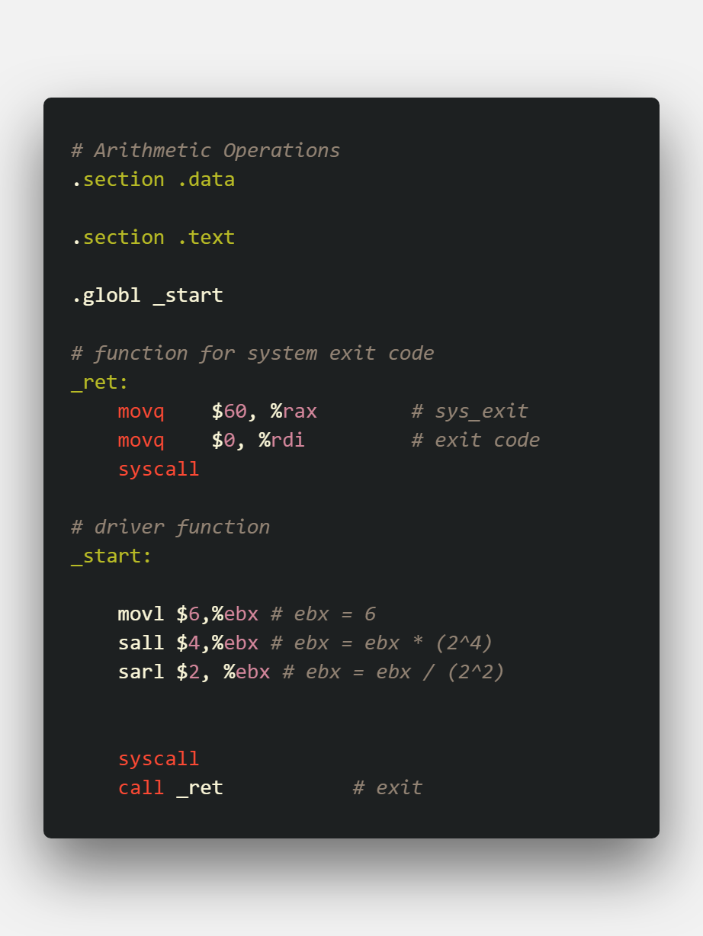

Figure 6 ASM code

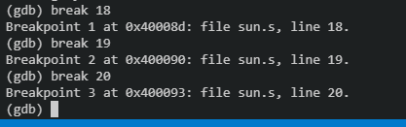

Figure 7 Adding breakpoints

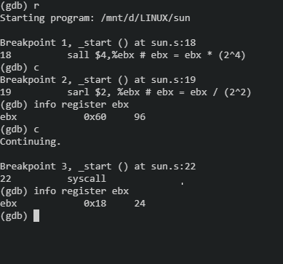

Figure 8 at breakpoint 2 , sall operates. at breakpoint 3 sarl operates

1. Analysis and Discussions

|  |  |
| --- | --- |
| Code | and <source> <destination> |
| Example | andl $20, %ebx |
| Explanation | Performs:  Destination = Destination AND Source  Description:  Performs a bitwise AND operation on the destination (first) and source (second) operands and stores the result in the destination operand location. The source operand can be an immediate, a register, or a memory location; the destination operand can be a register or a memory location. |

|  |  |
| --- | --- |
| Code | or <source> <destination> |
| Example | orl $20, %ebx |
| Explanation | Performs:  Destination = Destination OR Source  Description:  Performs a bitwise inclusive OR operation between the destination (first) and source (second) operands and stores the result in the destination operand location. The source operand can be an immediate, a register, or a memory location; the destination operand can be a register or a memory location. (However, two memory operands cannot be used in one instruction.) Each bit of the result of the OR instruction is set to 0 if both corresponding bits of the first and second operands are 0; otherwise, each bit is set to 1. |

|  |  |
| --- | --- |
| Code | xor <source> <destination> |
| Example | xorl $20, %ebx |
| Explanation | Performs:  Destination = Destination XOR Source  Description:  Performs a bitwise exclusive OR (XOR) operation on the destination (first) and source (second) operands and stores the result in the destination operand location. The source operand can be an immediate, a register, or a memory location; the destination operand can be a register or a memory location. (However, two memory operands cannot be used in one instruction.) Each bit of the result is 1 if the corresponding bits of the operands are different; each bit is 0 if the corresponding bits are the same. |

|  |  |
| --- | --- |
| Code | sal <shift_amt> <destination>  sar <shift_amt> <destination> |
| Example | sal $2, %ebx  sar $7, %ebx |
| Explanation | Performs:  Destination = bitwise shift destination shit_amt times, either to the left or to the right, depending upon usage of sal or sar respectively.  Description:  The shift arithmetic left (SAL) and shift logical left (SHL) instructions perform the same operation; they shift the bits in the destination operand to the left (toward more significant bit locations).  The shift arithmetic right (SAR) and shift logical right (SHR) instructions shift the bits of the destination operand to the right (toward less significant bit locations). |

1. Conclusions

To perform logical operations, we have instructions such as and, or and xor, that perform logical AND, logical OR and logical XOR bitwise respectively. These instructions take in two arguments, which is the source and the destination, and the operation is done for source and destination and the result is then stored in the destination.

To perform multiplication and division we use instructions such as sal, and sar, which are shift arithmetic left and shift arithmetic right respectively, these basically shift the bits in the register. Shifting the bits to the left multiplies the number by 2 and shifting the bits to the right divides the number by 2.

1. Comments
   1. Limitations of Experiments

The Experiment is limited to multiplying and dividing numbers using bitwise shifting operator by only powers of 2, such as 1, 2, 4, 8 .

2. Limitations of Results

Shit Left and Shift Right instructions can only multiply the operand by a positive value, i.e. the operand can only be multiplied by a positive number or divided by a positive number.

3. Learning happened

We learnt how to use bitwise logical operators on values stored in registers and also learnt how to multiply and divide numbers by using bitwise shifting operations.

4. Recommendations

Since shifting operations take way less machine execution cycles, they are preferred over div and mul instructions.

Signature and date Marks